**Drive installation method as shown in the following picture:**

1. Open the installation package:**Uart drive(CH340).**

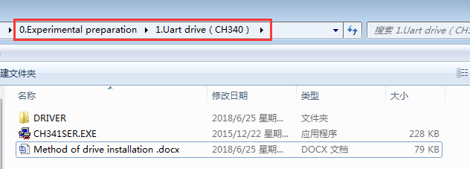

1. Double click to **CH341SER.EXE**

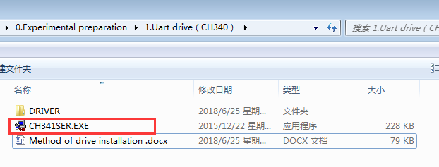

3.Double click to “**INSTALL**”

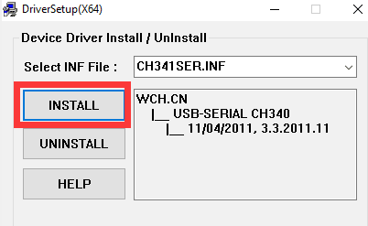

4.When appears to “The drive is successfully Pre-installled in adavnce”, that means that the driver has been installed, as shown in the following figure.

